**PRACTICAL # 1**

To study the working of basic gates.

**PRACTICAL # 2**

Consider the following equation and draw the circuit.

X = $\overline{A}$ B + AB

**PRACTICAL # 3**

Implement the given circuit.

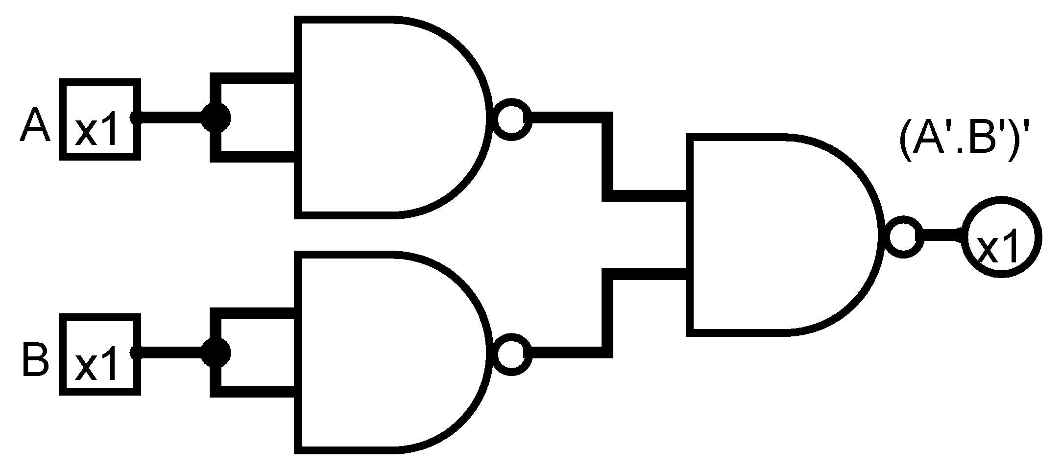

**PRACTICAL # 4**

Implement the given circuit.

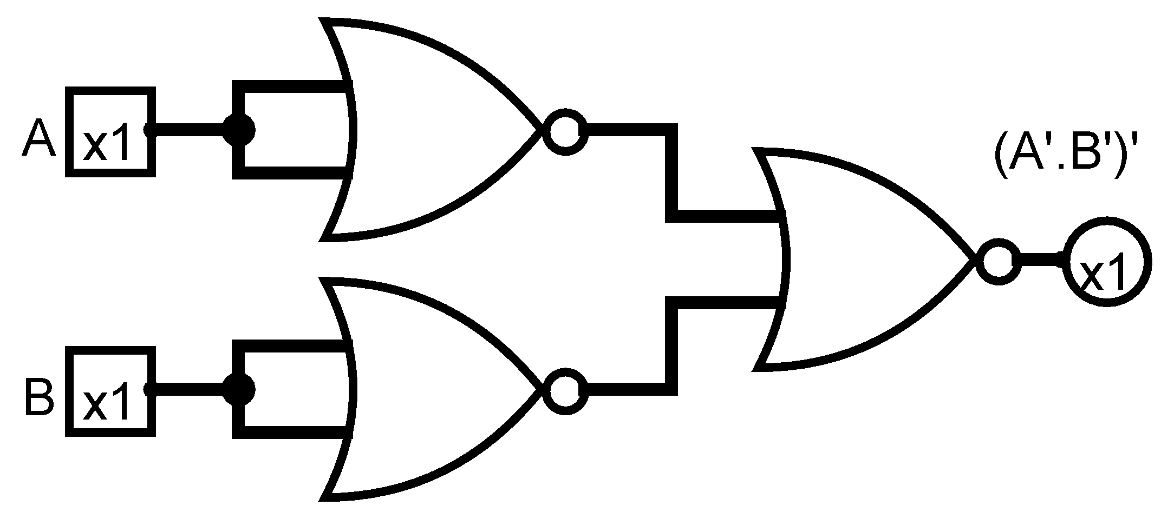

**PRACTICAL # 5**

Consider following standard sop

x = $\overline{A}$ $B$ C+A $\overline{B}$ C+ $\overline{A} \overline{B} \overline{C}$ + $\overline{A} \overline{B}$ C+AB $\overline{C}$

minimize it by using k.map and design circuit and compare Xstan = Xsimplified .

**PRACTICAL # 6**

Consider the following equation and draw the circuit using NAND gate only.

X = $\overline{A}$ + BC

**PRACTICAL # 7**

Consider the following equation and draw the circuit using NOR gate only.

X = $\overline{A}$ +BC

**PRACTICAL # 8**

Construct a truth table for y = $x^{2}$ where x is 3-bit input variable. Design a k.map for the truth table, minimize it and design circuit for minimize expression.

**PRACTICAL # 9**

Implement the circuit of half adder.

Sum = A⊕B

Carry = A.B

**PRACTICAL # 10**

Implement the circuit of full adder.

Sum = (A⊕B) ⊕C

Carry = AB + C(A⊕B)

**PRACTICAL # 11**

Implement the circuit of 2 bit parallel adder.

**PRACTICAL # 12**

Implement the circuit diagram of binary to gray code conversion.

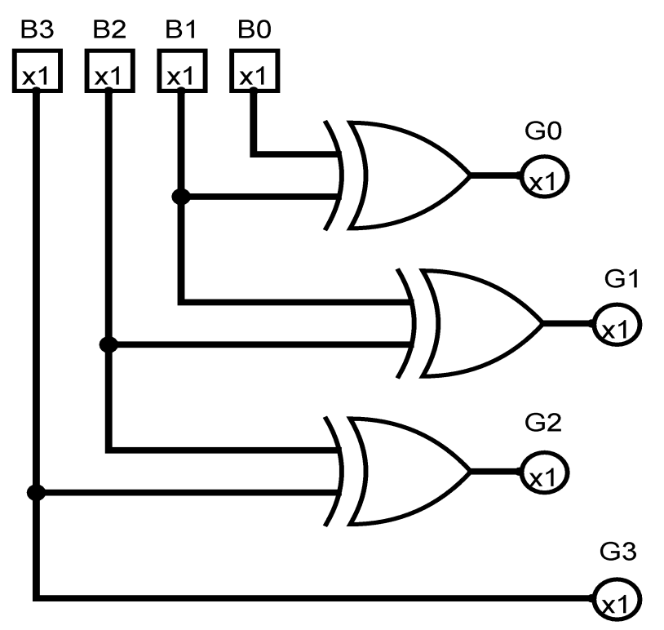

**PRACTICAL # 13**

Implement the circuit diagram of gray code to binary conversion.

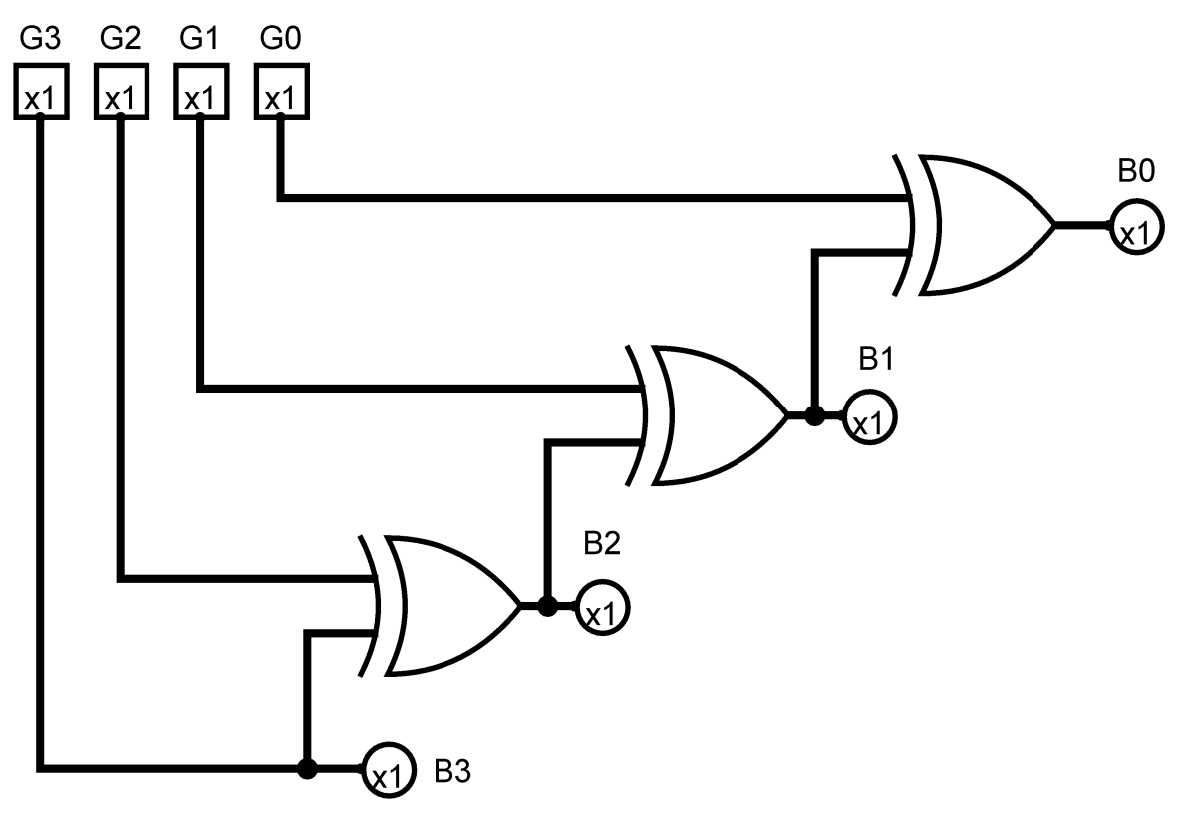

**PRACTICAL # 14**

Convert binary no into excess-3 code.